SOP for grants funding list

1) Enter the website for grants funding on:
http://grantscalendar.web.med.lu.se/

2) Log in with your LUCAT identity – enter your username and password.

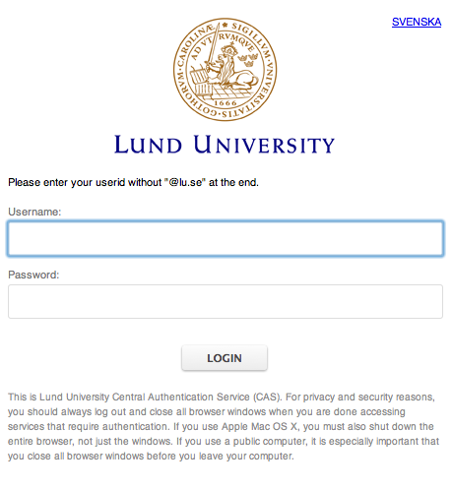

3) The page with grants funding will then appear with no list of grants and you need to make your first selection in order to display any grants.
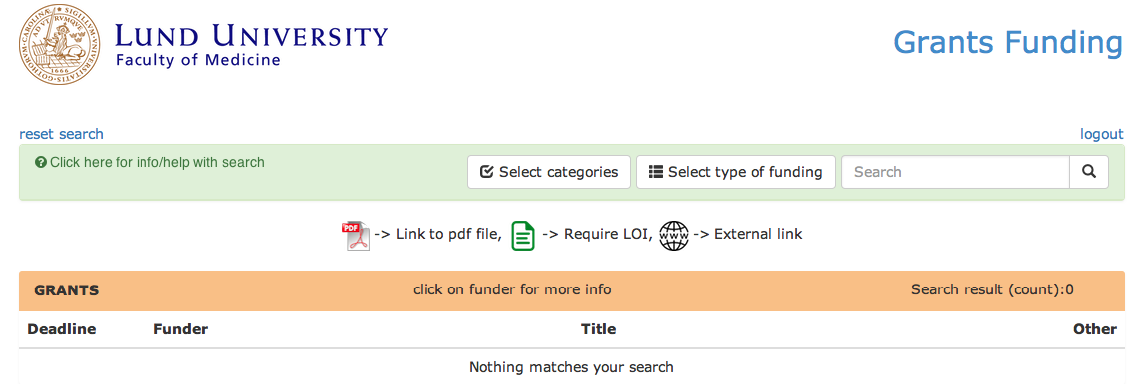

4) You can find your funding opportunities by selecting one of these three options.
a) Start by selecting categories (choose within Medical and Health Sciences). We recommend that you initially select all in the category using the button “Flip/Toggle all in this category”.
b) then select type of funding.
5) When you have made your choices click on the button “close and show selected categories/types” or “Show selected categories and close this page” depending on which page you were on.

6) The grant list will now display the grants available based on your selections (only 4 top options displayed below for simplicity).

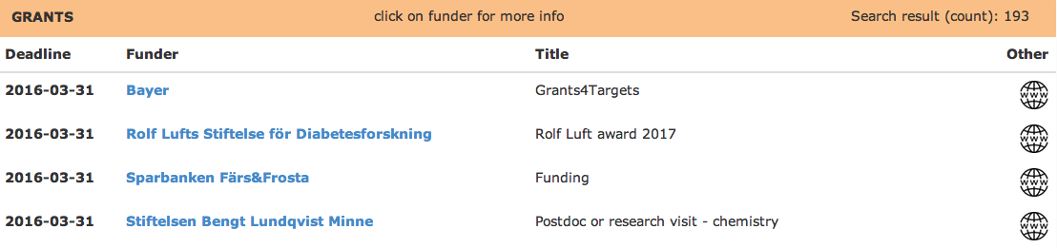

The displayed funding list is shown in chronological order based on Deadline for submission, with the closest deadline at the top. Some grants have no fixed deadline and can be applied to at any time – In those cases we have entered recurrent deadlines during the year, approx. 2-4 times per year, and added additional information about this grant being open for application at any time.

7) Funder is primarily given in English throughout the list, however, some Funders names are given in Swedish. A short summary of the call text is shown when clicking the blue text for the funder, in this case Sparbanken Färs&Frosta.

In the column Title one can find either the title of the grant and/or the category of the funding opportunity - for instance "research grant".

The column Other to the right can display 3 different symbols:
a) The link to the funder/announcement text is provided via
When possible, a direct link will be provided and when not possible a link to the founders website (or other) will be available.

b) When a link is not available a symbol for a pdf-file appear
Click on the pdf-file symbol to open the pdf.

c) When a Letter of Intent (LOI) is required prior to submission of a full application, or when internal university procedures must be complied to, the symbol for LOI appears. The deadline for the LOI will precede the deadline for the actual submission deadline and is needed to be taken into account.

8) You can reset your search at any time by clicking on this text

9) When you are done please logout via

10) Your latest search will be saved and used the next time when you log into the Grants Calendar using your LUCAT identity.

